7.2.12 Editors - 3D View - Header - Particle Mode menus
Detailed Table of content 1
Particle Mode - Select Menu 2
Less 2
More 2
Linked 2
Deselect Linked 2
Select Tips 2
Last Operator Select Tips 2
Action 2
Select Roots 2
Last Operator Select Roots 2
Action 2
Random 3
Last Operator Select Random 3
Percent 3
Random Seed 3
Action 3
Inverse 3
(De)Select All 3
Last Operator (De)Select All 3
Action 3
Invert 3
Deselect 3
Select 3
Toggle 3
Border Select 4
Lasso Select 4
Particle Mode - Particle Menu 4
Show/Hide 4
Delete 5
Last Operator Delete 5
Type 5

Detailed Table of content

Particle Mode - Select Menu

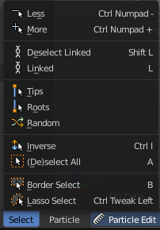
The Select menu in Particle mode provides you with some selection tools to edit the particles.

When you are in Emitter mode then most of the menu items are greyed out. This menu items are for Hair particles.

Less
Select less.

More
Select more.

Linked
Select linked geometry.

Deselect Linked
Deselect linked geometry.

Select Tips
Selects the end vertices of hair particles.

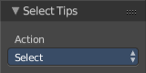
Last Operator Select Tips

Action
A dropdown box where you can choose what you want to do.

Select Roots
Selects the start vertices of hair particles.

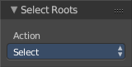
Last Operator Select Roots

Action
A dropdown box where you can choose what you want to do.

Random
Selects random objects.

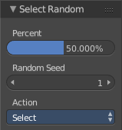
Last Operator Select Random

Percent
The Percentage of objects that should be selected randomly.

Random Seed
The Seed for the random number generator.

Action
Action is a drop-down box where you can choose if you want to select or to deselect random.

Inverse
Inverts the current selection.

(De)Select All
Toggles between select all and deselect all.

Last Operator (De)Select All

Action
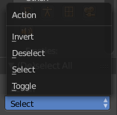
Action is a drop-down box where you can choose between different methods.

Invert
Inverts the selection.

Deselect
Deselects all.

Select
Selects all.

Toggle
Toggles between select all and deselect all.

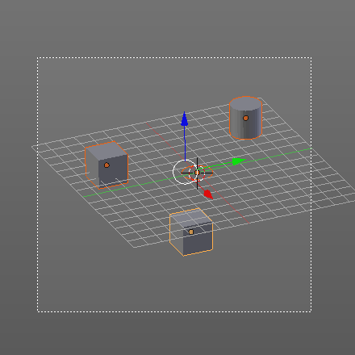
Border Select
Border select enters the Border Select mode. This is a special select mode where you can select elements by dragging a rectangle. And what's inside of the rectangle gets selected then. It adds to selection by default.
To subtract from selection hold down Shift key.
The selection gets applied when you release the mouse. You leave the mode automatically when you release the mouse.

Lasso Select
Lasso select enters the Lasso Select mode. This is a special select mode where you can select elements by dragging a form around what you want to select. And what's inside of the rectangle gets selected then. It adds to selection by default.
To subtract from selection hold down Shift key.
The selection gets applied when you release the mouse. You leave the mode automatically when you release the mouse.

Note
You can of course also start with clicking at the menu item. But this tool is by design a hotkey only tool. Hold down Ctrl , and select with left mouse button.

Particle Mode - Particle Menu

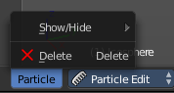
The Particle menu contains some tools to modify the particles.

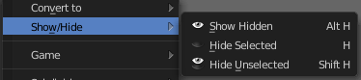
Show/Hide
Show/Hide is a menu. Here you can show or hide objects in the viewport. See chapter All Modes, all Object types - Show / Hide

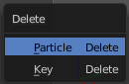
Delete
Brings up a popup where you can choose to delete either the selected particle(s) or the selected key(s).

Last Operator Delete

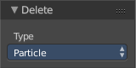
Type
Here you can again choose what type to delete. Particle or Key.

